Chap 1 – Introduction to IoT
Definition : The Internet of Things (IoT) refers to a network of physical devices connected to the internet that can collect, share, and act on data without requiring human intervention. These devices include everyday objects like smart thermostats, wearable devices, and industrial sensors.
Definition by ITU
- A global system connecting both physical and virtual things through communication technologies to support advanced services.
- Physical things are real-world objects that can be sensed, controlled, and connected (e.g., robots, equipment, environment).
- Virtual things are digital items that can be stored, processed, and accessed (e.g., software, multimedia content).

Why the society needs IoT
- We want to receive more data
- We want to control stuff
- We want to automate
- We want to reduce costs
- We want to make things faster
- We want to take better decisions
- We want to improve our life quality
- We want to feel more secured

. Key factors to IoT evolution (past) & its relevance for the future
- Growth of Wi-Fi, Zigbee, Z-wave
- Peer-to-peer connectivity
- Faster internet
- Cheap cloud storage and computing
- Better networking and cloud capabilities
- Advanced analytics: Big Data tools, AI (ML, DL, RL)
- Invention of low-cost devices (Arduino, Raspberry Pi, LoRa)
- Lower costs in memory and computing power

IoT Concepts
- IoT is a global structure using communication tech to connect and manage physical and virtual items for advanced services.

Key Components of IoT
1. Sensors and Actuators: Devices that collect and respond to data from the environment (e.g., temperature sensors, motion detectors).
Sensors (Data Collection)
- Sensors gather real-time data from the environment and convert it into digital signals:
Temperature sensors, Motion detectors, Pressure sensors, Gas sensors, Biometric sensors.
- Actuators receive commands from an IoT system and perform physical actions:
Smart locks (unlock doors remotely), Servo motors (used in robotics, Irrigation systems.
2. Connectivity: (Protocols-IoT Gateways): IoT devices communicate using Wi-Fi, Bluetooth, Zigbee, LoRaWAN, and cellular networks.

Protocols:
- Allow sensors to send data to the cloud.
- Ensure communication between devices through secure channels.
- Common protocols: Bluetooth, Wi-Fi, ZigBee, LoRaWAN, MQTT, cellular, etc.
- Network choice depends on power, speed, bandwidth, etc.

IoT Gateways:
- Act as bridges between sensors and the cloud.
- Translate protocols for seamless communication.
- Provide security (encryption, protection from attacks).
- Can preprocess or filter data before sending it to the cloud.
3. Data Processing: Cloud computing and edge computing help process and analyze IoT data in real time. After IoT devices collect data, it needs to be processed and analyzed to extract useful insights.
Cloud Computing (Centralized Processing)
- IoT data is sent to remote servers for large-scale storage and processing: Amazon AWS IoT, Microsoft Azure IoT, Google Cloud IoT, Used for big data analytics, AI-powered decision-making, and long-term storage.
Edge Computing (Local Processing)
- Data is processed closer to the device, reducing latency, Used in autonomous cars, real-time industrial monitoring, and smart surveillance, Faster response times.
Fog Computing (Hybrid Model): A mix of cloud and edge computing, Used in smart grids, smart cities, and high-speed automation.
4. IoT analytics and data management: Used to make sense of the vast amounts of analog data. Its role is to analyze the situation and formulate a decision based on it.
5. User Interface: Applications or dashboards allow users to monitor and control IoT devices remotely.
User Interface Types
1. Mobile & Web Applications: Google Home, Tesla Mobile App (used for smart home and vehicle control).
2. Voice Assistants: Amazon Alexa, Apple Siri, Google Assistant (control devices using voice commands).
3. Dashboards & Monitoring Panels: Industrial IoT dashboards (monitor machine performance).
4. Wearable Interfaces: Smartwatches and AR glasses.

Characteristics of IoT
1. connectivity
- IoT enables the seamless connection between devices, sensors, networks, and platforms, through Wi-Fi, Bluetooth, Zigbee, and cellular networks.
- Example: A smart home where thermostats, security cameras, and lighting systems interact through a central hub.
2. Things-Related Services
- IoT provides context-aware and intelligent services based on real-world conditions.
- Services adapt to specific user needs and device capabilities.
- Example: A smart parking system detects available spaces and guides drivers accordingly.
3. Heterogeneity
- IoT consists of diverse devices from different manufacturers using varied communication protocols and hardware architectures.
- Systems must support cross-platform compatibility.
- Example: An IoT ecosystem where Amazon Alexa, Google Nest, and Apple HomeKit work together despite different platforms.
4. Dynamic Changes
- IoT networks experience continuous changes due to:
- Devices turning on/off dynamically.
- Real-time data updates from sensors.
- Changes in device status, location, or environmental conditions.
- Example: A smart traffic management system adjusts traffic lights based on real-time congestion data.
5. Enormous Scale
- IoT networks support billions of devices worldwide, generating massive amounts of data.
- Requires scalable storage and processing solutions, such as cloud computing and edge computing.
- Example: Smart cities managing millions of connected streetlights, cameras, and sensors.

IoT High-Level Requirements
- Identification-based connectivity: IoT must establish connectivity based on a device’s unique identifier.
- Interoperability: Different systems must work together to share and use information seamlessly.
- Autonomic networking: IoT networks should manage themselves, adapting to different environments and device types.
- Autonomic services provisioning: Services should automatically collect, process, and respond to data based on predefined rules.
- Location-based capabilities: IoT should support location tracking and communication, ensuring compliance with security and legal requirements.
- Security: Strong security measures are needed to protect data and services from threats like unauthorized access or data breaches.
- Privacy protection: IoT must safeguard personal data during transmission, storage, and processing.
- High-quality and secure human-body-related services: IoT should support secure services related to human behavior and biometric data while adhering to different regulations.
- Plug and play: Devices should integrate seamlessly with IoT applications without complex setup.
- Manageability: IoT systems should be monitored and controlled to ensure smooth operation.

Machine-to-Machine (M2M) vs. IoT
- M2M: Involves autonomous devices communicating directly without human intervention. The communication method depends on the application.
- IoT: Can include M2M devices but typically aggregates data at a gateway or edge router before transmitting it over the internet.
Example:
- M2M: A heart rate sensor alerts a doctor about a patient’s condition.
- IoT: A smart pillbox reminds the patient to take medication and alerts family members if they forget. IoT operates on a broader scale than M2M.

Internet of Everything (IoE) vs. IoT
• IoT: A network of connected “things” that communicate using IP connectivity.
• IoE: Expands IoT by integrating people, processes, data, and things to create meaningful actions.
EX: IoE is the entire transportation system, including vehicles, drivers, traffic signals, and pedestrians. IoT is a part of IoE.

Internet of Everything - Components
1. Things: Connected objects that gather and share data (e.g., smart devices, sensors).
2. People: Users interacting with connected devices and data.
3. Data: The collected and processed information.
4. Process: The system ensuring data reaches the right person at the right time.
Challenges in IoT
- IoT devices rely on cloud computing for storage and processing, but connectivity issues, latency requirements, and low power sensors present challenges.
- Real-time applications (e.g., autonomous vehicles) may struggle with delays from cloud dependence.

IoT and Individual Privacy
- IoT collects and processes user data while ensuring privacy and security.
- Privacy concerns include unauthorized surveillance, uncontrolled data usage, weak authentication, and security risks.
- Strong privacy protection is necessary during data transmission, storage, and processing.

Policies and Regulations in IoT
- Key Policy Issues:
- Who regulates IoT? ICT sector or others?
- Impact of regulations on different industries.
- Need for international cooperation (standards, spectrum, security, and data protection).
- Regulatory Challenges:
- Licensing of IoT providers.
- Spectrum regulations for different technologies.
- Addressing and numbering IoT devices.
- International roaming and interoperability.
- Privacy, security, and consumer protection.
- Competition and smart city governance.
- National vs. International Regulations:
- National policies on spectrum allocation, licensing, and roaming must align with international standards to avoid conflict

Chap 2 - Advanced Topics in Data Science
1. Smart Cities
Smart cities use the Internet of Things (IoT) to enhance citizens’ quality of life by efficiently managing resources while focusing on economic, social, and environmental sustainability.

Key Components
- Sensors: Monitor utilities (electricity, water, traffic, air quality, etc.) and capture real-time data.(characteristics of quantity and bandwidth)
- Gateways: Aggregate data and take localized actions to prevent faults.
- Communication Infrastructure: Connects gateways to cloud servers for data analysis.
- Server Farms: Store and analyze data to provide useful insights via mobile and other platforms.

IoT Use Cases in Smart Cities
- Pollution control through environmental sensors
- Automated crime detection using smart cameras
- Smart irrigation for parks and public spaces
- Smart parking solutions to guide drivers to available spots

2. Smart Grid
A smart grid is a communication network built on top of the electricity grid that gathers and analyzes data to predict power supply and demand, improving power management.

Limitations of the Existing Grid
- Traditional grids have one-way interaction, making it hard to respond to rising energy demands.
- Smart grids introduce two-way communication, enhancing efficiency, reliability, and security.

Main Components
- Smart Appliances: Reduce energy use during peak hours (e.g., smart air conditioners, refrigerators, and dishwashers).
- Smart Meters: Enable automated billing, detect system failures, and send outage notifications.
- Smart Substations: Monitor and control power distribution using transformers, circuit breakers, and capacitor banks.
- Phasor Measurement Units (PMUs): Help maintain grid stability by measuring electrical waveforms.

Smart Grid and Renewable Energy
- Enables integration of wind, solar, and electric vehicles into the grid.
- Provides automation to balance power supply based on real-time demand.
- Helps manage variability in renewable energy production through real-time data analysis.

3. Healthcare
IoT in healthcare enables real-time monitoring of patients’ conditions using smart medical devices connected to smartphone apps.
IoT Use Cases in Healthcare
- Remote patient monitoring reduces hospital readmission rates(Reduces hospital overcrowding , Increases comfort).
- Wearable devices collect health data (blood pressure, oxygen levels, ECGs, etc.) and share it with physicians.
- Predictive healthcare models improve disease prevention and management.

4. Agricultural & Environmental
IoT in agriculture and environmental monitoring improves food production efficiency, predicts disasters, and ensures sustainable farming practices.
IoT Use Cases in Agriculture & Environment
- Smart Irrigation & Fertilization: Optimizes water usage to improve crop yield.
- Livestock Health Monitoring: Tracks movement and detects illnesses before they spread.
- Robotic Farming: Automates tasks like planting and harvesting.

5. Supply Chain Management (SCM)
IoT revolutionizes supply chain management by improving tracking, storage conditions, and logistics efficiency.
-IoT Use Cases in SCM
- Real-Time Location Tracking: GPS-enabled IoT devices help track shipments and materials.
- Storage Condition Monitoring: Sensors ensure optimal conditions for sensitive products like food and chemicals.
- Route Optimization: Identifies delays and suggests alternative routes for faster deliveries.
- Warehouse Management: Helps locate and manage inventory efficiently.
- Automated Administration: IoT-enabled verification of goods triggers supplier payments and stock updates.

6. Government and Military
IoT applications in government and military sectors enhance security, infrastructure monitoring, and battlefield efficiency.
IoT Use Cases in Government & Military
- Terror Threat Analysis: Detects suspicious activity through IoT pattern analysis.
- Smart Sensor Bombs: Deploys networks to detect enemy movements.
- Government Asset Tracking: Monitors highways, bridges, and public infrastructure.
- Military Personnel Tracking: Provides real-time location services for soldiers.

Chap 3- IoT Architecture, Modules & Hardware – Simplified Breakdown
1. IoT Architecture – The Big Picture
The Internet of Things (IoT) is all about connecting devices so they can communicate. But making this work isn’t simple—IoT systems are complex, made of many different devices (sensors, controllers, etc.) that all need to work together. That’s where IoT architecture comes in. It’s the overall design that makes sure everything runs smoothly from start to finish.
IoT architecture typically has 4 levels:
  - Sensors (Data collection)
  - Local Processing/Storage (Preprocessing the data)
  - Network & Internet (Sending data out)
  - Cloud (Heavy-duty processing, analysis, and storage)

2. Level 1: Sensors – Where It All Starts
Sensors are the heart of IoT—they pick up data from the environment (temperature, wind speed, air quality, etc.).
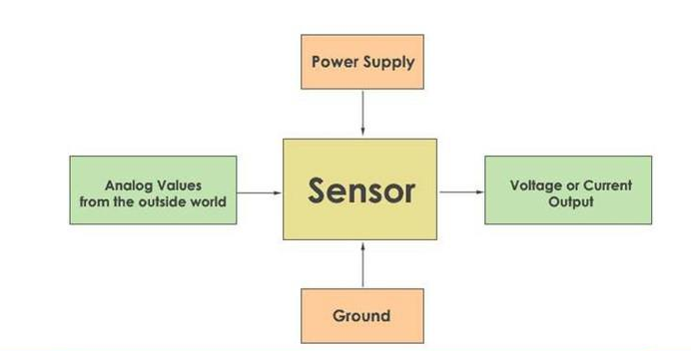
There are two types:
• Analog Sensors: Give a continuous range of values (like 0 to 5V). More sensitive, but can be affected by noise.
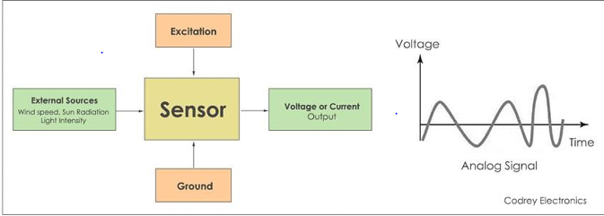
• Digital Sensors: Give either 0 or 1 (like a switch). More stable and noise-resistant.
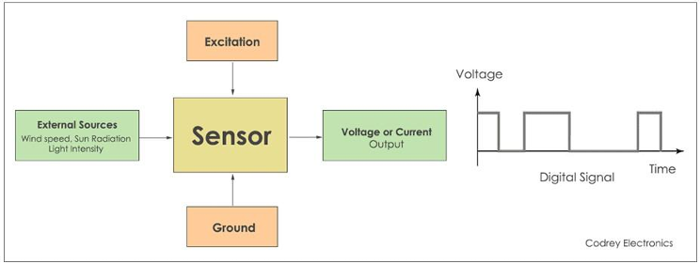

3. ADC (Analog to Digital Converter) – Translating for the Microcontroller
Because most sensors output analog data but computers work with digital data, you need an ADC to translate between the two. Think of it like a translator converting a continuous signal into 1s and 0s. The better the ADC, the more precise the data translation.
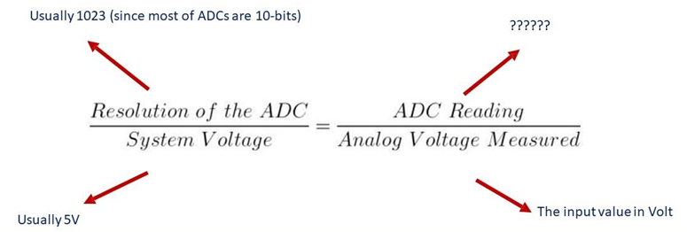
Types of Sensors in IoT Systems
In any IoT setup, sensors play a vital role. They’re the very first layer—responsible for capturing real-world data and feeding it into the system. Different types of sensors exist depending on the nature of the data they’re meant to capture. Here’s a breakdown of some key ones:
Analog Pressure Sensors: Analog pressure sensors detect pressure changes and convert them into analog voltage signals. They usually measure pressure in psi (pounds per square inch). These sensors operate based on the relationship between the input voltage and the applied pressure. The output is continuous, allowing precise pressure monitoring in real-time environments.
Digital Pressure Sensors: Unlike their analog counterparts, digital pressure sensors have a built-in ADC (Analog-to-Digital Converter). This means they automatically convert analog pressure signals into digital outputs. These are used in: Leak detection in pipelines and cable systems, Industrial automation, Drone systems, Water level management systems.

-Analog Temperature Sensors: These sensors monitor temperature by detecting resistance variations. The resistance value changes with temperature, producing a corresponding analog voltage. Applications include: Monitoring water tem, Measuring ambient air temp, HVAC systems (Heating, Ventilation, Air Conditioning), Food processing environments.

-Wind Speed / Wind Direction Sensors (Anemometers)
These use ultrasonic techniques to measure wind characteristics. They are widely used in: Weather and environmental monitoring stations, Maritime environments like harbors and seaports, Road tunnel ventilation systems, Oceanography stations.

-Reflex Sensors: A reflex sensor has a transmitter and receiver. It emits a light beam, and when an object interrupts this beam, it triggers a changeover signal. Used in: Monitoring flow in industrial processes, Liquid level measurement, Tank monitoring.

-Fork SensorS: A more sensitive version of reflex sensors, fork sensors can detect extremely small objects—down to micrometers in size. Common in: Automated sorting systems, Power supply control, Detecting small gaps or holes.

-Analog Hall Effect / Magnetic Sensors (Position Sensors): These sensors detect magnetic fields and translate them into voltage output. When a magnetic field is present, the output voltage rises. Applications: GPS systems, Metal detectors, Motion and speed detection.

-Radar Sensors: These work by sending out short microwave signals that bounce back from an object, helping determine distance and speed. Primarily used to: Measure liquid levels in industrial tanks or rivers.

-Solar Radiation Sensors: Using photovoltaic diodes, these sensors measure solar energy hitting a surface. They’re used in: Solar energy farms, Irrigation planning, Meteorological studies.

Humidity Sensors: They measure the amount of water vapor in the air—crucial for weather forecasting and environmental control. Found in: Medical diagnostic tools, Air compressors and fridges, Humidity transmitters, Dew detection systems.

-Air Quality / Gas Sensors: These sensors monitor the presence and concentration of gases like CO₂, CO, and SO₂. They play a vital role in: Meteorological and health monitoring, Smart home systems, Ventilation and air purification.

-Light Sensors: They detect the brightness level of an environment and convert that into a current. Common uses include: Automatic screen brightness in mobile devices, Smart streetlights, Light-sensitive toys, Cameras and TVs.

-Rainfall Sensors: These are essentially rain gauges used by meteorological stations to measure how much rain falls in a particular location. Measurement is in millimeters.

-Soil Moisture Sensors: These sensors analyze the moisture and salt content in soil, as well as soil temperature. Extremely useful in agriculture and environmental monitoring.

-Water Level Sensors: These measure how deep the water is in natural and man-made reservoirs like lakes, dams, and tanks. Depending on their type (analog or digital), they are used for: Groundwater monitoring, Surface water tracking, Water tank level alerts.

4. Level 2: Local Processing – Mini Brains Near the Sensors
This is where the data gets a quick filter or first pass. Not everything a sensor detects is useful, so this stage decides what’s worth sending to the cloud.
This level uses microcontrollers like:
- Arduino: Simple and beginner-friendly, runs one program at a time (firmware), no operating system.
- Raspberry Pi: More like a small computer—can run full OS (Linux), multitask, and connect to the internet.

5. Wearables – IoT You Can Wear
Wearable devices are smart gadgets you wear—like fitness trackers, smartwatches, or even medical sensors. They have built-in microcontrollers and sensors, and they usually work in three layers:
- Sensor layer – picks up data from your body (heart rate, motion, etc.)
- Control layer – handles Bluetooth or WiFi connections
- Cloud layer – sends the data to apps or servers for analysis

6. Level 3: Network and Internet – Getting the Data Out
Once local processing is done, useful data is sent over the internet using different communication protocols, like:
• CoAP and MQTT (both made for machines to talk to machines)
• HTTP (standard web communication)
• XMPP (used in chat-like systems)
Each protocol is suited for different kinds of devices and needs.

7. Level 4: Cloud Processing – Making Sense of It All
Finally, the cloud takes all the gathered data and:
• Stores it
• Processes it
• Makes predictions or triggers actions
But here’s the catch—right now, a lot of unfiltered and irrelevant data gets sent to the cloud, which makes the system inefficient. The ideal scenario would be to send only the useful data, already cleaned up a bit by local processing.

